7 Ways the South Rules Comfort Food
Source: http://dish.allrecipes.com/why-the-south-rules-comfort-food/?internalSource=hn_carousel%2003_7%20Ways%20the%20South%20Rules%20Comfort%20Food&referringId=16091&referringContentType=recipe%20hub&referringPosition=carousel%2003

There are so many culinary classics of the American South. From crispy fried chicken and fluffy biscuits to Country Captain and Hoppin’ John, smoked country ham and red-eye gravy to sweet potato pie, Southern food boasts big, big flavors and a whole mess a soul!
That’s why, when you need comfort food, it’s time to turn to the Southern kitchen. And here are 7 reasons why the South does comfort food best:

1) They Praise the Lard
It’s not your imagination. Biscuits really are best down here. It’s because soft Southern winter wheat flour bakes them up light and fluffy. Oh, and Southern cooks don’t fear the lard. A little lard makes for crispy, flavorful food.
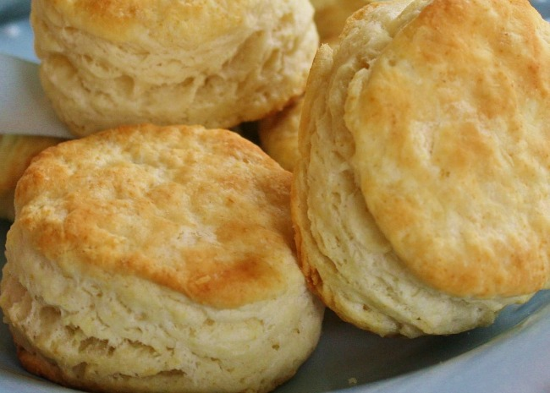
Greg’s Southern Biscuits
Biscuits are must for breakfast with eggs and gravy, lunch as a leftover fried chicken sandwich, and dinner with fried chicken and country gravy. Dessert? Try a biscuit as the base for strawberry shortcake. Or better yet, slather chocolate gravy all over it.

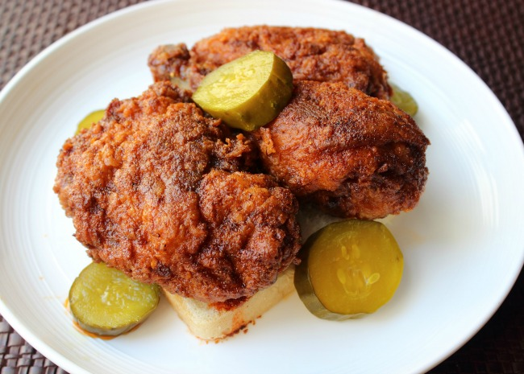

Nashville Hot Chicken
“If you’ve never had Nashville Hot Chicken, we’re talking about an ultra-crispy fried chicken doused with a cayenne-infused glaze, and by ‘glaze’ I mean melted butter and lard.” — Chef John

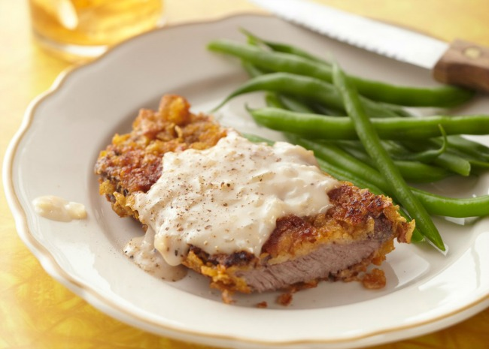

2) They Fry Steaks, Too
According to chicken fried steak’s semi-official origin story, this mighty meal was introduced into the Lone Star State by German immigrants settling in the Fredericksburg and New Braunfels area — the German veal dish Wienerschnitzel being the prototype.

Down South, they fry chicken. And they fry steaks like they fry chicken. And, uh, they fry chicken like they fry chicken. It’s a little thing called Chicken Fried Chicken. Sound crazy? More like crazy delicious.

Country Fried Steak and Milk Gravy
Chicken fried steak requires a milk-based gravy. It’s the law. “I have never used a recipe for this dish in my life, as I learned to cook in my g’ma’s Southern kitchen,” says Jay Lynne. “But this is how I have always done it!

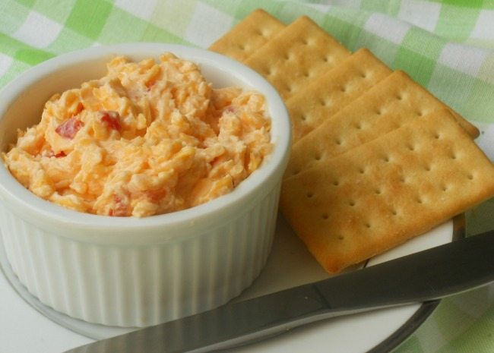
3) They Put Pimentos in Cheese
Ah yes, “the caviar of the South.” Pimento cheese is a creamy spread with kick — a cheese relish, if you like. Spread it on crackers, smear it onto hamburger buns and sandwich bread, drop a dollop into grits, add it to deviled eggs.
Southern Pimento Cheese
“This wonderful version of pimento cheese can be used for grilled cheese sandwiches or served alongside your favorite fried green tomatoes.” — QUEENREYNEY

Fried Mac and Cheese Balls
Mac and Cheese as finger food! With Cheddar and Italian cheeses, plus pimento cheese, this mac is cheesed to the max. “Super cheesy and absolutely one of my faves,” says Erin. “No need for spoons with this mac dish!”
Pimento Cheese Jell-O Salad
An old family recipe, it combines lemon gelatin with pimento cheese, pineapple, and whipped topping. Let it rest in the fridge overnight to blend flavors.

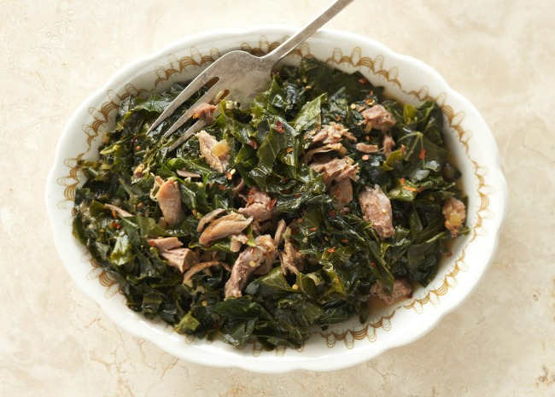
4) Southern Has Soul
Part of the genius of Southern food is in turning cheaper cuts of meat into tender slow-cooked wonders and transforming various vegetables and grains into flavorful greens, grits, black-eyed peas, and sweet potato pies.
Braised Collard Greens
“My Grandma Ollie-Belle made the best ‘greens,'” says THYME4MA. “This recipe is as close to hers as I could come. The ‘pot-liquor’ is the key to great greens! Serve with fresh green onions and black-eyed peas with rice.”

Soul Smothered Chicken
“You can’t just go to any restaurant and get smothered chicken like you would if you went down to the urban neighborhoods in Houston,” says Veronica. “This meal of browned chicken in a savory chicken gravy sauce is best when served over a bed of white rice.”
Southern Style Pig Tails
“Pig tails are great as a meat dish with turnip greens, black-eyed peas, or boiled cabbage,” says KERYNE. “My recipe cooks the tails twice, and the result is a crispy crackling covering the tail that you can eat or save for crackling in cornbread.”
Find more Soul Food Recipes.

5)The South Owns BBQ
You can get pretty good barbeque anywhere these days. But the best barbeque? That’s a Southern thing. Southerners can agree on that. But everything else is up for argument. Only in the South can the style of barbeque provoke such raw emotional responses. In fact, whether you prefer barbequed “pulled” pork shoulder or ribs could be a product of where you grew up. Same goes for the ingredients you want in your barbeque sauce and whether you’re working with pork or beef. It’s a Southern thing.
Kathy’s Award Winning Barbeque Sauce
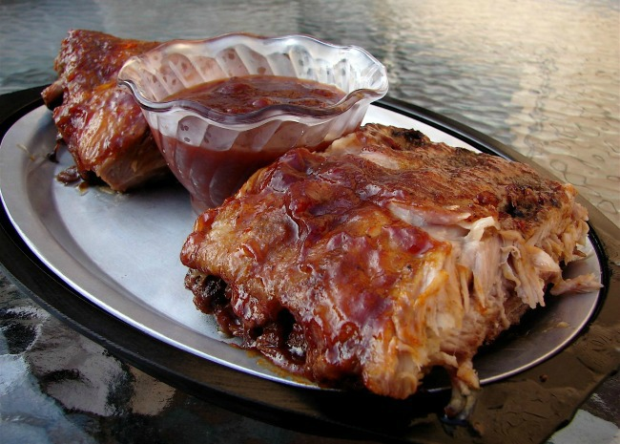
Southern Grilled Barbecued Ribs
“These ribs will have the smoky flavor without all the grilling time,” says MYSST. “It takes just 30 minutes on the grill to give the ribs that smoky flavor Southerners expect. You can use this recipe for spare ribs too, just bake for 15 minutes longer.”
North Carolina-Style Pulled Pork
“A spicy rub and a zesty vinegar sauce turn pork into a North Carolina favorite,” says Doug. “Delicious, especially when smoked with hickory chips on a charcoal grill.”

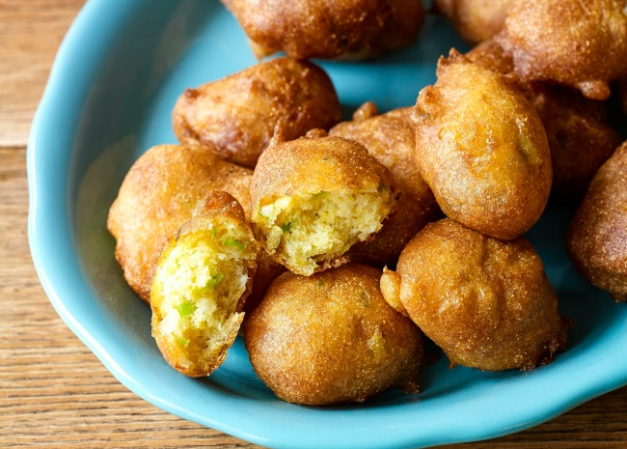
6) Catfish, Hush Puppies, and Slaw
It’s the trifecta. “Hush puppies are a great Southern tradition,” says Irlynda. “Along with buttermilk coleslaw and Southern-fried catfish. Why not use all that buttermilk together in all your recipes?” Excellent question. Here are the top-rated recipes you’ll need.
Buttermilk Hush Puppies

Buttermilk Hush Puppies | Photo by Allrecipes

Southern Fried Catfish
“So good!” says Taranoelle. “The fish was perfectly flavored and was so yummy. A great southern classic!”
Nana’s Southern Coleslaw
A vintage coleslaw recipe handed down through the family, it’s similar to the slaw from that famous chain of chicken restaurants. Try it on pulled pork, too.

7) Because…New Orleans
Did we save the best for last? New Orleans is a comfort food category unto itself. Beignets for breakfast, po’boy sandwiches for lunch, gumbo for dinner, Bananas Foster for dessert — and that’s just for starters. Here are a few Crescent City classics:
Real N’awlins Muffuletta
“These gigantic sandwiches were invented a century ago at Sicilian Deli here in New Orleans,” jenn. “The spicy, tangy olive salad is what really sets this meat and cheese sandwich apart. A genuine muffuletta should be made on oven-fresh Italian bread topped with sesame seeds.”
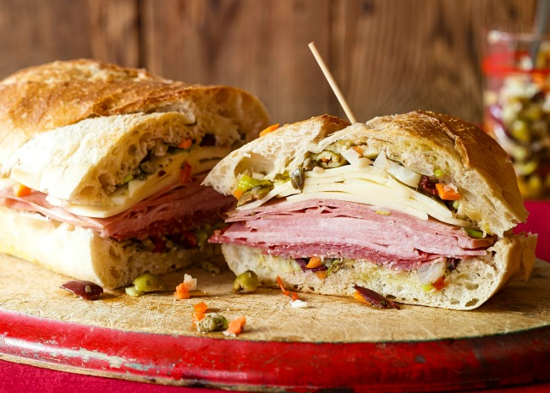
Real N’awlins Muffuletta | Photo by Allrecipes

New Orleans-Style Barbequed Shrimp
This top-rated New Orleans-style, grill-free barbequed shrimp recipe boasts big, big flavors: in the shrimp marinade, the shrimp stock (which you make with the shrimp shells), and in the spicy reduction sauce. It’s super easy. Serve over white rice with the amazing sauce spooned over.
Louisiana Crawfish Etouffee
“Here in Louisiana, there’s nothing better than this classic during crawfish season,” says Bonnie. “This recipe is easy and can be substituted with shrimp when crawfish are out of season. Even better when served with hot garlic French bread! Start cooking the rice first since this is a quick and easy dish.”
Find more Cajun and Creole Recipes.

