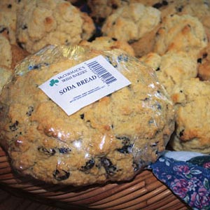
Source: Best Irish Soda Bread Recipe photo by Taste of Home
Best Irish Soda Bread Recipe

This recipe is similar to the one passed down through generations of my Irish family. I rarely touch a mixer because kneading by hand makes the bread taste so good.—Kerry McCormack, Marietta, GA

TOTAL TIME: Prep: 30 min. Bake: 30 min.
MAKES: 16 servings

Ingredients
- 4 cups all-purpose flour
- 1/4 cup sugar
- 2 teaspoons baking powder
- 1 teaspoon salt
- 1/2 teaspoon baking soda
- 1 cup cold butter, cubed
- 2 eggs, lightly beaten
- 1 cup buttermilk (I used light buttermilk)
- ¼ cup raisins and 1 tablespoon caraway seeds
(* I used golden raisins because that’s what I had)

Nutritional Facts
1 slice: 255 calories, 12g fat (8g saturated fat), 57mg cholesterol, 343mg sodium, 31g carbohydrate (7g sugars, 1g fiber), 5g protein.

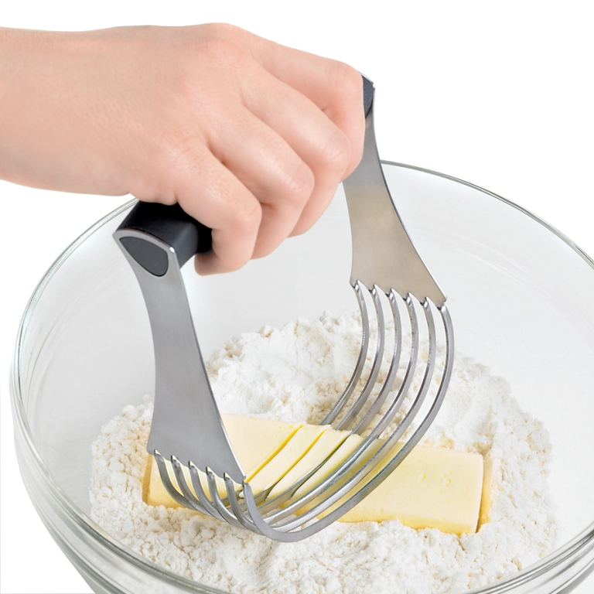
Directions

- In a large bowl, combine the flour, sugar, baking powder, salt and baking soda. Cut in butter until crumbly. Use a pastry blender if you have one or two knives to cut the butter into the flour. In a small bowl, whisk eggs and buttermilk; stir into flour mixture just until moistened. Fold in raisins and/or caraway seeds. Turn onto a lightly floured surface; it is not going to get to be a firm dough like a yeast dough bread so you don’t need to add flour. Gently knead 5-6 times.

- Divide dough in half; shape each portion into a round loaf. Place 6 in. apart on a greased baking sheet. Cut a cross into top of each loaf.

- Bake at 375° for 30-35 minutes or until golden brown. Transfer to a wire rack. Yield: 2 loaves (8 slices each).

