BETH’S FOOLPROOF FRENCH MACARON RECIPE
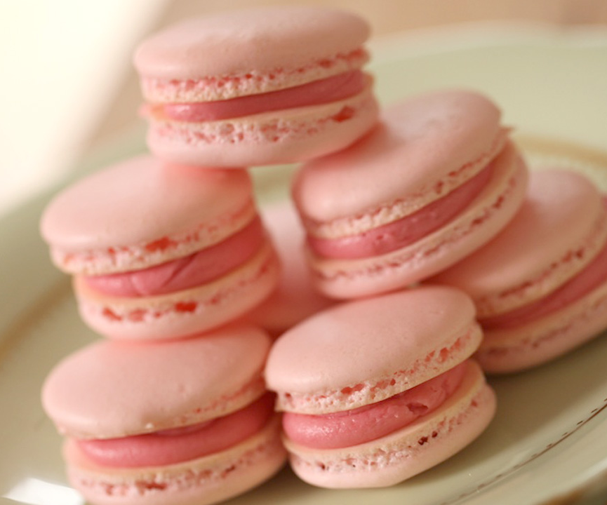

Author: Beth Le Manach
Recipe type: Dessert
Cuisine: French
Serves: 24 sandwiched cookies

INGREDIENTS
- 3 Egg Whites (at room temperature)
- ¼ cup white sugar (50 g)
- 2 cups confectioners sugar (200 g)
- 1 cup almond flour (120 g)
- pinch of salt
- ¼ tsp cream of tartar (2 ml)
- RASPBERRY BUTTER CREAM
- ¼ cup salted butter (60g)
- ¾ cup powdered sugar (75 g)
- 1 cup (150 g) fresh raspberries, worked through a sieve to extract 3 tbsp of juice
INSTRUCTIONS
- Preheat oven to 300F degrees
- Beat egg whites until foamy, then add salt, cream of tartar and white sugar for 8-10 mins. TIP: #1 egg whites should be room temp. To create room temp eggs, submerge in warm water for 5 mins.
- Whip until they form a peak that stands upright. Think Seattle Space needle.
- Then add the food coloring. TIP#2 Color does fade as it cooks, so do a shade or two darker than you want them to be.
- TIP#3 Sift almond flour, and powdered sugar. What remains will be the larger lumps of almond pieces. Just discard those, or use them to snack on :) You want a really fine powder mixture to create a smooth and pretty on top to your cookie.
- Fold flour/sugar mixture into the egg white mixture. TIP#4 This is where all your hard work can really go wrong. Under mix and your macaroons will be lumpy and cracked when the bake with no feet, over mix and your macaroons will be flat and won't have feet, the mark of a well-made macaron. In my experience 65-75 turns of your spatula when folding is about the right amount of time. But again, it can be tricky, depends on how strong you are, Ha! So it can take a few tries to get it right. But when you do, the trumpets will blare and you will feel SO accomplished!
- Transfer batter to a pastry bag.
- Pipe out 1 inch rounds on a baking sheet lined with parchment paper.
- TIP#5: tap the pan hard at least 2-3 times to release the air bubbles. This will prevent the tops of your macaroons from cracking.
- TIP#6 Let them sit out for 20-30 mins, or up to an hour if you want. This will allow them time to dry out a bit before hitting the hot oven. They should be "tacky" to the touch, but not stick to your fingertips. This is another important step to assuring your macarons develop feet! When they dry out they can't spread out in the oven, and are forced to rise up. That's what creates the feet!
- Bake for 20 mins. DO NOT UNDER BAKE, even if they look done! Otherwise they will stick to your tray.
- Meanwhile mix the buttercream. Whip butter with an electric mixer until pale and fluffy. Slowly add sugar. Then place sieve on top of a bowl the same size. Work raspberries through the sieve with a spatula, pushing them through, mashing them around until you extract their juice. You want 3 tablespoons of juice.
- Add juice to buttercream, and whip until combined. Transfer to a pastry bag, fitted with a small tip (about ¼ " in diameter)
- Reverse cookie shells on their backs, and pipe a small mound of filling on one of them. Top with the other shell et Voila!
- If not eating right away, keep refrigerated.

