Four Cheese HEart Ravioli
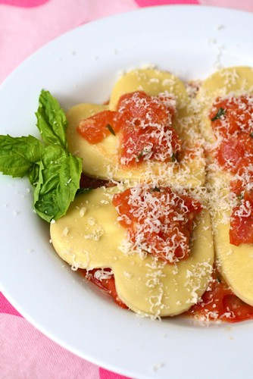
Even though we are very much into the spirit of Valentine’s Day, we’re not so much into the going out for dinner and paying too much for a meal I could have made easily at home. Plus, for me so much of the fun is in the planning and preparation of a nice meal. I always look forward to coming up with a special meal to celebrate the occasion. Homemade pasta is certainly an impressive entree that is not nearly as difficult as many people think. Even filled and shaped pastas like this heart-shaped ravioli are easy and fun to make.
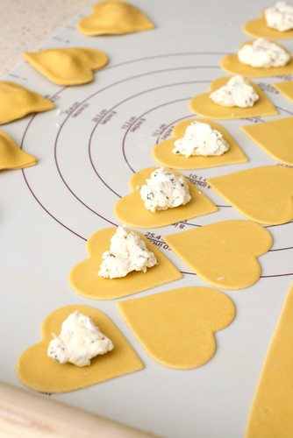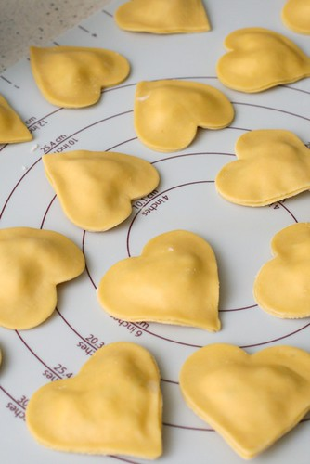

INGREDIENTS
½ cup part-skim ricotta
½ cup shredded mozzarella
½ cup shredded fontina
½ cup shredded parmesan
1 clove garlic, finely minced
¼ tsp. dried oregano
¼ tsp. dried basil
¼ tsp. dried parsley
¼ tsp. salt
Freshly ground black pepper, to taste
1 batch fresh homemade pasta
Marinara sauce, for serving

DIRECTIONS

In a medium mixing bowl, combine the ricotta, mozzarella, fontina, parmesan, garlic, and spices. Mix well to blend. Roll out homemade pasta into long, thin sheets. To make heart-shaped ravioli, use a heart-shaped cookie cutter to cut out pasta shapes. Place about 2 teaspoons of filling in the middle of half of the heart shapes, leaving a clear edge around the perimeter. Dip a finger in water and lightly brush around the edges of a heart topped with the filling. Place one of the remaining pasta hearts on top and press the edges of the pasta shapes together to seal around the filling, being careful to press out any excess air. Repeat with the remaining dough shapes.

Bring a large pot of salted water to boil. Cook the ravioli until al dente, about 5 minutes. Serve in warmed bowls with marinara sauce.

