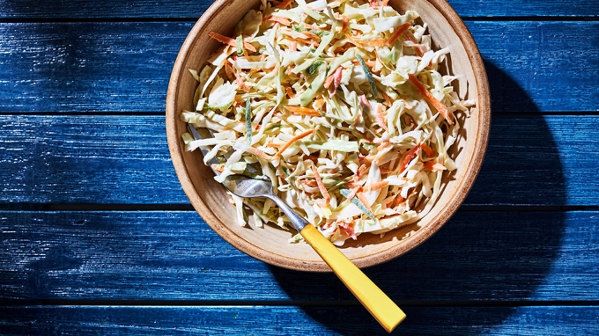
HOMEMADE COLE SLAW RECIPE
If not serving immediately, cover and refrigerate it for up to 3 days.

SERVINGS: 5 CUPS

INGREDIENTS
- 1/2 large head green cabbage (about 1 1/2 pounds)
- 3 scallions, white parts only
- 1/4 medium green bell pepper, seeded and coarsely grated
- 1/4 medium red bell pepper, seeded and coarsely grated
- 1 medium carrot, peeled and coarsely grated
- 1/2 cup cider vinegar
- 1 teaspoon salt
- 2 teaspoons sugar
- 1/2 cup low-fat or regular sour cream (do not use nonfat)
- 1/2 cup low-fat or regular mayonnaise (do not use nonfat)

DIRECTIONS
Cut the cabbage into 1/8-inch shreds and place in a large mixing bowl. Cut the scallions crosswise into very thin slices and add the peppers and carrot, mixing well.
Combine the vinegar, salt, sugar, sour cream and mayonnaise in a large measuring cup and whisk until smooth. Add to the prepped vegetables and mix well. Serve immediately, or cover and refrigerate until ready to use.

