Homemade Pasta
Source: http://www.food.com/recipe/homemade-pasta-128586

Reviews: This is by far the BEST, simplest recipe for homemade pasta out there; This was so easy and exact.
Directions:

Combine:
3 eggs ___________(measures), 3 tablespoons water _______ (measures), 3 teaspoons olive oil ________ (measures), and 1 ½ teaspoons salt __________ (measures) in a medium bowl and mix together well with a fork. _________________(mixes with the fork)

- Add ½ cup flour and mix with the fork until all lumps are gone.
- _______________

- Keep adding flour little by little until a non-sticky ball is formed.
You will use between 3 & 3 ¾ c of flour, depending on the
- humidity, etc. ___________________

- Knead WELL about 10 minutes. Add light coating of flour as needed,
- until a firm ball is formed. Do not over add flour.
- ___________________

- Wrap it in plastic wrap and let sit for 30 minutes. If completing
Recipe in class, stop here for the day. Make sure it is wrapped well and labeled. __________

DAY 2:

REMINDER: Don’t forget to continuously coat the pasta maker and the pasta sheets with flour before putting the pasta through the mixer each time.
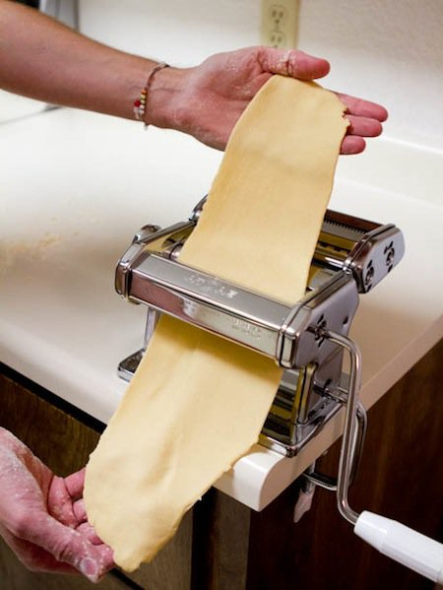
- Cut off billiard ball-sized pieces and put them through
- the Pasta machine starting with the widest setting
- and changing the knob down a size each time you
- put the pasta through. ______________

- Make it as thin as possible before you think it will begin
to break and be too thin. You also do not want pasta that is too thick, it will be rubbery and chewy when cooked. Then add the spaghetti/fettucine attachment and move the handle to the spaghetti or fettucine part _____________________ . As soon at the cut pasta begins to come out the other side, someone would should catch it and make sure it stays straight and doesn’t bunch up in a pile. _________________
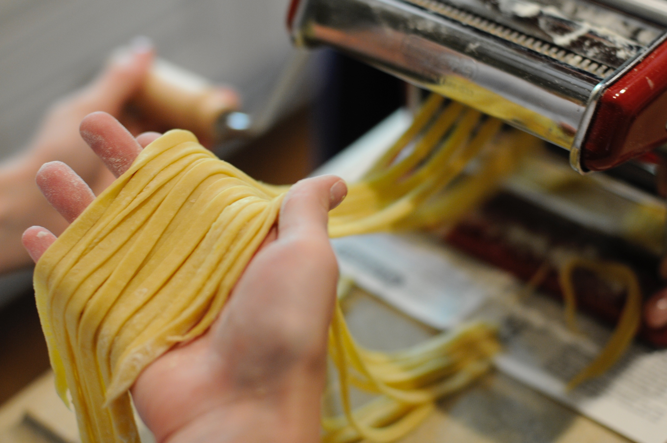

- OR you can also roll them out flat on a well-floured board if you don’t
have access to the pasta maker. (Maybe 1-2 mm. thick).
- Then, fold 3x and cut noodles with a sharp knife roughly 4 mm. thick.

- Stretch out pasta and let dry (either hanging or on a parchment
covered baking sheet) for a few minutes up to an hour. ________________ Put on parchment on pan and label.

- Cook in a pot of boiling, slightly salted water for 2-3 minutes or until
- the pasta floats to the top. __________________

