How to Cook Corned Beef Brisket
Source: http://startcooking.com/how-to-cook-corned-beef-brisket

Brisket is the name of a particular “cut” of beef, which tells you what part of the cow it came from. Corned Beef is a cut of meat (brisket) that has been cured (or pickled) in a seasoned brine. For this recipe you will need to purchase a corned beef brisket.
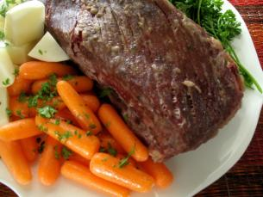
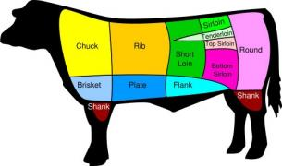

Flat Cut Brisket
Corned beef brisket, (also known as salt beef if you live in the UK) is great when served with potatoes and your favorite vegetable.
This recipe is REALLY simple. All you need to do to cook a corned beef brisket are three things:
- Put the corned beef brisket in a large pot
- Cover it with water
- Bring it to a boil then simmer for 3-5 hours

When buying a brisket you can choose between a point cut and a flat (or plank) cut.
The point cut is a rounder, thicker cut with more fat on it then the flat cut.

This photo of the leaner flat cut shows off the grain of the meat beautifully. This is really important when it comes time to cut the brisket. After cooked, the brisket MUST be cut across the grain or it will be just about impossible to chew!
Briskets come shrink-wrapped. It’s best to cut open the shrink wrap packaging in your (CLEAN!) sink. Although this flat cut brisket had very little juice in it, the point cut package was filled with brine which you don’t want all over your counter tops! Rinse the meat off with cool running water.

Each of these briskets weighs about 3 pounds. That should be enough to feed about 4-6 people.

Corn beef brisket requires long, slow, moist cooking, either on the stove top or in the oven.
Set the brisket in a large heavy pot with a lid.
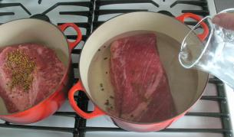
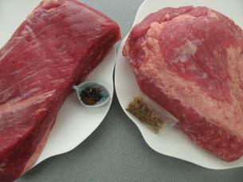

- Cover the brisket with water.
- Cover the pot and bring it to a boil.
Then reduce the heat to simmer and let simmer about 4 hours. By then it should be really tender. The meat will have also shrunk by about a third!
