New Jersey Sloppy Joe

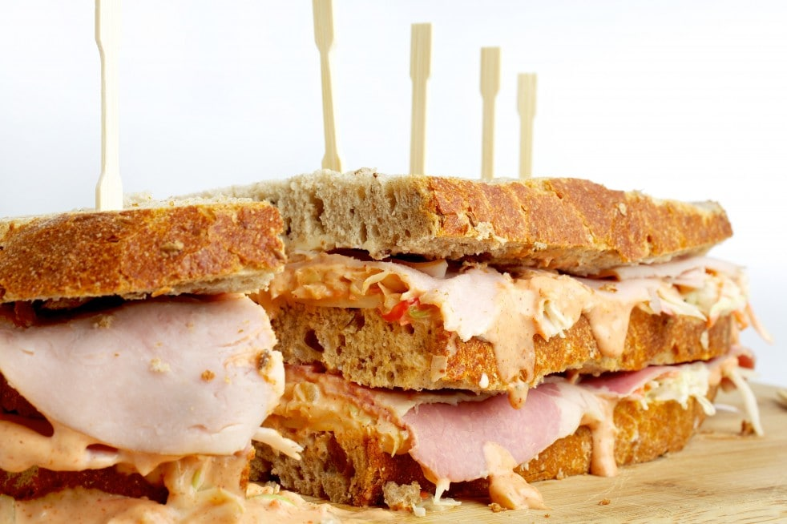
In certain parts of the Garden State, the term "sloppy Joe" refers not to the ground-beef-and-tomato-sauce sandwich but to a no-cook deli classic. The double-decker sandwich combines two meats, Swiss cheese, coleslaw and Russian dressing on rye bread.
INGREDIENTS:
- Three 1/2-inch-thick slices fresh rye bread, cut lengthwise from a whole 9-inch loaf
- 1 tablespoon unsalted butter, at room temperature
- Six 1-ounce slices Swiss cheese
- About 1 1/4 cups homemade or store-bought coleslaw (see related recipe)
- About 1/3 cup Russian Dressing, or as needed (see related recipe)
- 4 thin slices beef tongue, corned beef or pastrami (5 to 6 ounces total)
- 4 thin slices oven-roasted turkey breast (3 to 4 ounces total)
DIRECTIONS:
Cover a cutting board with plastic wrap. Lay the bread slices on top.
Spread the butter on both sides of 1 slice, and one 1 side of each of the two remaining slices, taking care to cover the slices completely.
Begin to layer the sandwich by overlapping 3 slices of Swiss cheese so they almost cover 1 slice of one-side-buttered bread. Spoon a layer of coleslaw over the cheese (using half of it), then carefully spoon/spread some of the Russian dressing over the coleslaw. Cover with the slices of tongue or corned beef or pastrami, overlapping them to make sure that no dressing shows through. Top with the two-sided-buttered bread slice.
Continue building the sandwich by layering the remaining 3 slices of Swiss cheese over the buttered bread, then spoon the remaining coleslaw over the cheese. Spoon/spread the remaining Russian dressing over the coleslaw, then layer the turkey slices over the dressing, overlapping as needed. Top with the last piece of bread, buttered side down.
Trim off the crusts (and any overhanging bits of coleslaw, meat or cheese); the cook gets to eat the scraps.
If you're not serving the sandwich right away, wrap it in plastic wrap and refrigerate for up to a few hours.
Insert long toothpicks to help keep the sandwich together as you cut it; use a serrated knife to divide the sandwich into three equal sections, then cut each portion in half lengthwise (creating six equal pieces). Serve right away.

