Sfogliatella
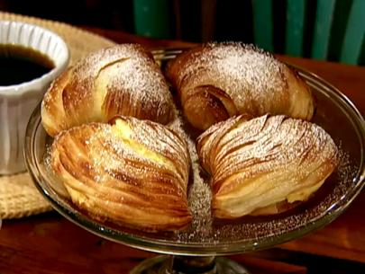
Recipe courtesy of Alex Guarnaschelli
Yield:15 to 18 pastries
Dough:
2 cups all-purpose flour
1 cup semolina flour
1/8 teaspoon kosher salt
1 cup unsalted butter, chilled and cut into small cubes
1/2 cup water
1/4 cup shortening
1 egg, beaten with 1 tablespoon water, for egg wash
Confectioners' sugar (about 1/2 cup)
Filling:
1 cup whole milk
1/4 cup semolina flour
1 cup ricotta cheese
1 egg
1/4 cup granulated sugar
2 tablespoons finely chopped mixed candied orange and lemon bits
Ground cinnamon, for dusting
2 nonstick baking sheets
Directions
In a large bowl, sift together the all-purpose flour, the semolina flour and salt. Use your fingers to work the butter into the dough until it forms pea-like balls. Alternatively, sift the dry ingredients into the food processor and pulse the butter into the mixture until it is blended and relatively smooth. Work the water in with your fingers (or in the mixer). Turn the dough out onto a flat surface and roll it into a ball. Wrap it in plastic wrap and press it down. Refrigerate for at least 1 hour.
In a medium saucepan, bring the milk to a simmer. Whisk in the semolina flour and cook, stirring constantly with a wooden spoon, until the mixture thickens, 3 to 5 minutes. If it forms lumps as it cooks, whisk until smooth. Transfer the milk and flour mixture to a bowl to cool slightly, about 10 minutes. Stir in the ricotta, the egg, sugar. Add the candied orange and lemon bits and sift a dusting of cinnamon over the surface. Stir to blend. Taste for seasoning and refrigerate until ready to use.
Remove the dough from the refrigerator and divide in half. Flour a flat surface and roll 1 of the halves into a rectangle about 14 inches by 24 inches. The shorter end of the rectangle should be close to you. The dough should feel very thin. The thinner the better! Brush the entire rectangle with a layer of the shortening. Sprinkle it with an even dusting of confectioners sugar. Gently and evenly roll it up into itself like a jelly sponge roll. Roll carefully, taking care that it rolls up very tightly. Refrigerate for at least 2 hours. Use a sharp knife to cut the roll into 1 to 1 1/2-inch thick pieces. Repeat the same process with the other half of the dough.
Preheat the oven to 375 degrees F.
Put 1 of the dough rounds in your hand and, with the other hand, press your thumb into the middle of your other hand (and, therefore, into the dough) and start to stretch the dough. You don t want to push so much that you make a cavity just yet. First, concentrate on making the dough round bigger and flatter. When it is about the size of a large clam shell, start to smooth and push down in the middle so it forms a cavity a lot like a large clam shell. You want to finish with a cone with an opening of about 3 inches and the smaller, tapered end about 1-inch. Brush a little shortening on the dough and turn it inside out, cupping the dough cone between the length of your index finger and thumb. Carefully spoon 2 large spoonfuls of the filling into the cone. The cone should be fairly filled and go to the edges of the opening with a thin layer of the filling. Close the mouth by carefully folding the cone opening over itself. The same as if you had 2 halves of a clam shell and were closing it up. Gently press the edges of the opening, together. Arrange on a nonstick baking sheet. Repeat with all of the dough, until both of the baking sheets are filled. Brush each with the egg wash.
Cook's Note: The Sfolgliatella can be frozen, at this point, and baked, as needed, at a later date, if desired. In fact, they bake better when baked from their frozen state.
Put the trays in the center of the oven and bake until golden brown, 30 to 35 minutes. Remove from the oven and allow them to rest a few minutes on the baking sheet.
After the Sfogliatella have rested for a few minutes, sprinkle them with another dusting of confectioners' sugar and put each baking sheet squarely under the broiler. Do not walk away! Stay there and watch as the sugar slowly browns the top. If the layer of sugar was light and you want to make it a little browner, repeat with another dusting of sugar and another minute under the broiler. Allow them to rest a few minutes, then transfer them to a serving platter, dust with confectioners' sugar and serve.
Read more at: http://www.foodnetwork.com/recipes/alexandra-guarnaschelli/sfogliatella-recipe.html?oc=linkback

Almond Bear Claws

1/3 cup almond paste
2 3/4 cups ground almonds
1/2 cup white sugar
1 pinch salt
2 tablespoons butter
2 egg whites
1/2 teaspoon almond extract
2 teaspoons amaretto liqueur
3 pounds puff pastry
1 egg
1 tablespoon water
3 tablespoons sliced almonds, for garnish
3 tablespoons confectioners' sugar for dusting

In a large bowl, beat almond paste with an electric mixer to break it apart. Add the almonds, sugar, and salt; continue to mix until the almond paste is no longer lumpy. Stir in the butter, egg whites, almond extract and amaretto liqueur on high speed until its as fluffy as you can get it. Set aside.

Using half of the dough at a time, roll it out on a lightly floured surface into a rectangle that is about 8 inches wide and 1/4 inch thick. Trim the edges of the dough.
Cut the dough in half lengthwise to make two 4 inch wide strips.
Preheat the oven to 400 degrees F (200 degrees C). Line baking sheets with parchment paper.
Fill a pastry bag halfway with the almond filling and pipe a stripe of filling down the center of each strip. Whisk together the egg and water. Brush onto one edge of each strip. Fold each strip over the filling and press gently to seal it. Brush each piece with egg wash and sprinkle sliced almonds over the top. Cut into 3 to 4 inch pieces, then cut 1/2 inch slits into the sealed edge to make the ''claws''. Place the bear claws at least two inches apart on baking sheets. Refrigerate and repeat with the second half of the dough.
Bake in the preheated oven until almonds are toasted and pastry is golden brown, 25 to 30 minutes. Cool and dust with confectioners' sugar right before serving.

NAPOLEON RECIPE

Ingredients
- 1 1/2 (17.5 ounce) packages frozen puff pastry sheets, thawed
- 1/4 cup cornstarch
- 4 cups milk, divided
- 1/3 cup cake flour
- 7/8 cup white sugar, divided
- 3 eggs, separated
- 1 tablespoon butter
- 1 teaspoon vanilla extract
- 1 (12 ounce) jar apricot jam
- 3 cups sifted confectioners' sugar
- 1 tablespoon lemon juice
- Add all ingredients to list

Directions
- Preheat oven to 350 degrees F (175 degrees C).
- Roll out three sheets of puff pastry, each to the same size and a thickness of 1/8 inch. Prick with a fork, and place on baking sheets.
- Bake in preheated oven until golden, about 10 minutes.
- In a medium bowl, combine cornstarch and 1/2 cup milk with fingers until smooth. Stir in cake flour and half the sugar. Beat in egg yolks. Set aside.
- In a saucepan over medium heat, bring remaining milk and remaining sugar to a rolling boil. Stir in egg yolk mixture; continue stirring and bring to a boil again. Remove from heat and stir in butter and vanilla. Let cool.
- In a small saucepan or in the microwave, heat the jam until runny.
- Place one sheet of pastry on a board. Spread with cooled pastry cream to a thickness of 1/2 inch. Place a second pastry sheet over the cream. Brush with fruit glaze. Spread remaining pastry cream over glaze. Top with final pastry sheet and gently compress layers, using a baking sheet to press.
- To make icing, beat together confectioners' sugar and lemon juice with enough of the egg whites to make a creamy consistency like that of a cream soup. Working quickly, color a small portion of the frosting with red food coloring. Frost the top and sides of the assembled pastry with white icing. Pipe parallel lines of red icing on top of dessert, then draw a pick or knife crosswise through icing to make the traditional design. Let icing set before cutting into bars.

Puffed Pinwheel Dessert
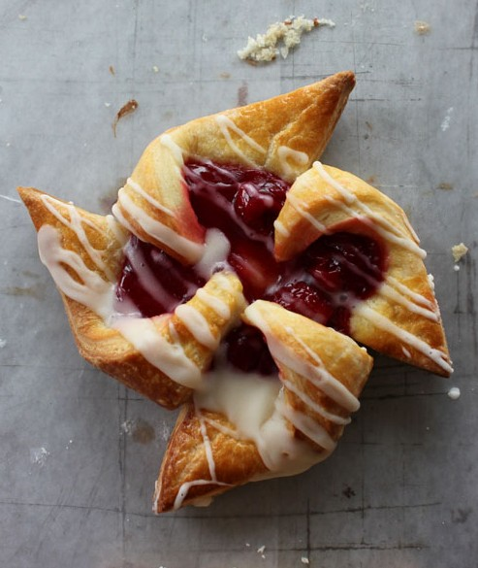
Cherry Pinwheel Pastries
Pastry Ingredients
4½ tsp instant yeast
1 tsp sugar
½ cup warm water (110 degrees F)
4 cups all purpose flour
1/3 cup sugar
½ tsp kosher salt
¾ cup unsalted butter, cut into small cubes
3 eggs
½ cup whipping cream
Filling Ingredients
1¼ cups cherry jam
Egg Glaze Ingredients
1 egg
1 tbsp water
Icing Glaze Ingredients
½ cup icing sugar
2 tbsp cream
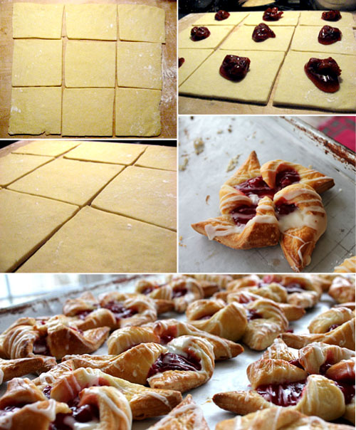
from dough to danish.
Directions
- In medium bowl, combine yeast, 1 tsp sugar and warm water; let stand until foamy & frothy, about 5 minutes.
- Meanwhile, in large bowl, whisk together flour, 1/3 cup sugar and salt; cut in butter with pastry blender or two knives used in a scissor-like fashion until mixture resembles cornmeal.
- Whisk 3 eggs and ½ cup cream into (now frothy) yeast mixture; pour into flour mixture and stir to incorporate, until moistened.
- Cover bowl with plastic wrap and refrigerate for 8 hours or overnight.
- Preheat oven to 350 degrees F; butter two large baking sheets; set wire racks over waxed paper.
- Remove dough from refrigerator, divide dough in two (return one half of dough to the fridge), and use a rolling pin to roll out one half of the dough into a 12-inch square on a lightly floured board; cut into nine 4-inch squares.
- Dollop 1 tbsp filling into the center of each square of rolled dough.
- On each square, slice a 2-inch cut from each corner in toward the center; fold every other tip in toward the center (pressing firmly), forming the pinwheel shape (easy peasy!) Transfer pinwheels to baking sheets using a spatula.
- Repeat with remaining dough and filling.
- Beat 1 egg with 1 tbsp water in a small cup; brush lightly over pastries using a pastry brush.
- Bake in preheated (350 degree F) oven for 25-30 minutes — switching baking sheets on oven racks halfway through baking time — until beautifully golden.
- Transfer pastries to prepared wire racks to cool completely.
- Meanwhile, to prepare the icing glaze: in a small bowl, mix icing sugar with 2 tbsp cream. Using a fork, drizzle icing over pastries in zig-zag pattern.

Apple Turnover Recipe

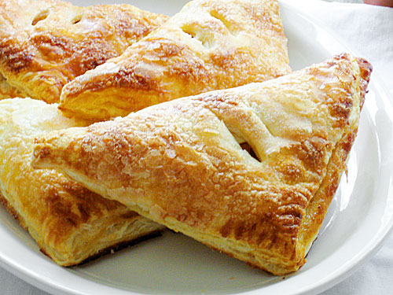

Ingredients
- 2 tablespoons lemon juice
- 4 cups water
- 4 Granny Smith apples - peeled, cored and sliced
- 2 tablespoons butter
- 1 cup brown sugar
- 1 teaspoon ground cinnamon
- 1 tablespoon cornstarch
- 1 tablespoon water
- 1 (17.25 ounce) package frozen puff pastry sheets, thawed
- 1 cup confectioners' sugar
- 1 tablespoon milk
- 1 teaspoon vanilla extract
- Add all ingredients to list

Directions
- Combine the lemon and 4 cups water in a large bowl. Place the sliced apples in the water to keep them from browning.
- Melt butter in a large skillet over medium heat. Drain water from apples, and place them into the hot skillet. Cook and stir for about 2 minutes. Add brown sugar, and cinnamon, and cook, stirring, for 2 more minutes. Stir together cornstarch and 1 tablespoon water. Pour into the skillet, and mix well. Cook for another minute, or until sauce has thickened. Remove from heat to cool slightly.
- Preheat the oven to 400 degrees F (200 degrees C).
- Unfold puff pastry sheets, and repair any cracks by pressing them back together. Trim each sheet into a square. Then cut each larger square into 4 smaller squares. Spoon apples onto the center of each squares. Fold over from corner to corner into a triangle shape, and press edges together to seal. Place turnovers on a baking sheet, leaving about 1 inch between them.
- Bake for 25 minutes in the preheated oven, until turnovers are puffed and lightly browned. Cool completely before glazing.
- To make the glaze, mix together the confectioners' sugar, milk and vanilla in a small bowl. Adjust the thickness by adding more sugar or milk if necessary. Drizzle glaze over the cooled turnovers.

