Pate a Choux Recipe for: ECLAIRS & CREAM PUFFS
Makes about 12-15 puffs or eclairs
Ingredients:
½ cup butter (1 stick)
1 cup boiling water
½ teaspoon salt
1 cup sifted flour (sift flour then measure)
4 eggs, unbeaten

Directions:
- Preheat oven to hot (400 degrees). Prepare 2 baking sheets with parchment paper.
- In a medium saucepan, put the 1 stick of butter, add the 1 cup boiling water and heat over high heat, stirring occasionally, until butter is fully melted.
- Then turn heat to low and add ½ teaspoon salt and 1 cup sifted flour, both at once, and stir vigorously over low heat, until mixture leaves sides of pan in a smooth compact ball.
- (See Photo 1 to see what these above steps will look like)
- Immediately remove from heat, then quickly add the 4 unbeaten eggs, one at a time beating with spoon until smooth after each addition. After last egg has been added, beat until mixture has satin-like sheen. (See Photo 2 to see what these steps will look like)

- Spoon the mixture into an uncut plastic disposable pastry bag. Do not fill to the top. Make sure you do not have any big air bubbles in your pastry bag. Twist at the top while pushing the mixture toward the bottom of the pastry bag. Use a rubber-band to tie the top of the pastry bag closed. Then cut about a ¼- ½ inch hole in the bottom of the bag depending on the size of cream puff or éclair you want. Be ready to pipe onto the parchment paper- it will begin to come out as soon as you cut the hole.

(See Picture 3 for an image of how piping puffs or eclairs would look)

- FOR CREAM PUFFS: If you do not have a pastry bag or even a zip lock bag, you can drop dough by rounded tablespoons, 3 inches apart, on parchment paper covered cookie sheet or greased cookie sheet.
- Dip your finger in water and then flatten out the peak that points up in the center of each mound. Bake 50 minutes without peeking. Cream Puffs should be puffing high and golden. Cool on wire cooling rack.

- FOR ECLAIRS: If you do not have a pastry bag or even a zip lock bag,
shape a mound of mixture with spatula into 4 x 1 1/2 inch strips. Bake in preheated hot oven (400 degrees) for 40 minutes or until light golden brown. Cool on wire cooling rack.

CREAM FILLING:
1/3 cup granulated sugar
2 tablespoons cornstarch
1/8th teaspoon salt (1/8th is half of 1/4th tsp)
2 cups of milk
2 egg yolks, slightly beaten
2 tablespoons butter
2 teaspoons vanilla

- Mix 1/3 cup sugar, 2 tablespoons cornstarch and 1/8th teaspoon salt in a 2-quart saucepan.
- Stir in 2 cups milk gradually. Cook over medium heat, stirring constantly, until mixture thickens and boils. Boil and stir 1 minute.
- Stir at least half of the hot mixture into a bowl with the 2 egg yolks. Stir well. Then add this mixture back into the saucepan with the hot mixture. Boil and stir 1 minute.
- Remove from heat; stir in 2 tablespoons butter and 2 teaspoons vanilla. Let cool.

To Fill: Slit top of puffs almost all the way around, or cut slits in each side of eclairs with sharp knife. Easiest and neatest way is to use a pastry bag to pipe the cream filling into the cream puffs or eclairs.

Chocolate GLAZE:
Melt 1 package (6 ounces) semi-sweet chocolate pieces with 1 tablespoon vegetable shortening in a small bowl set over hot, not boiling, water to melt. Let cool 2 minutes. Spoon over puffs or eclairs. Or, dust with 10X (confectioners') sugar, if you wish. Serve at once or refrigerate.

Cooking eclairs and crème filling being made
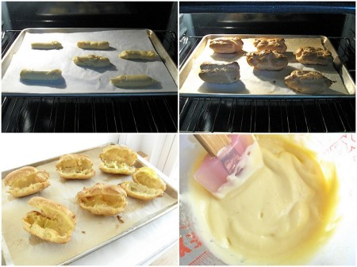

Picture 1 Picture 2
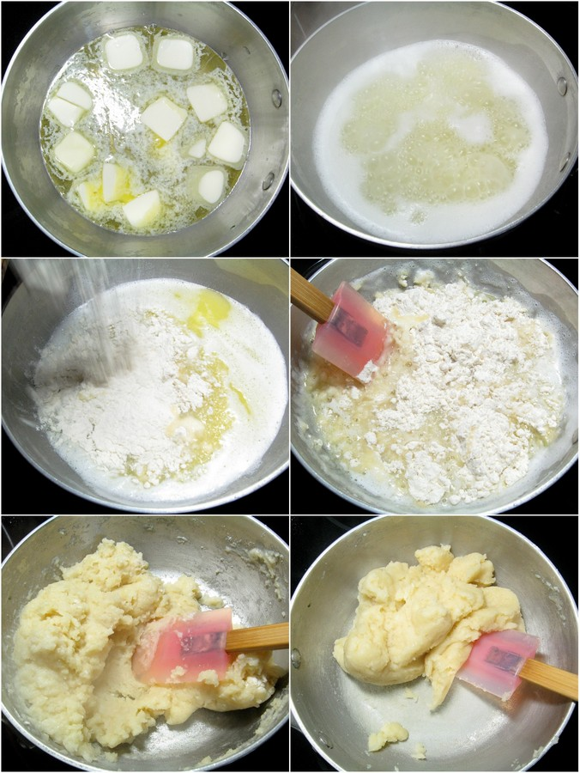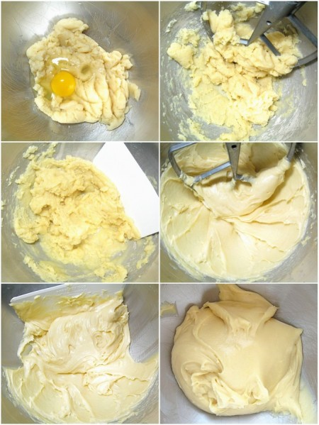

(Above images from Kingflour.com)

Picture 3: 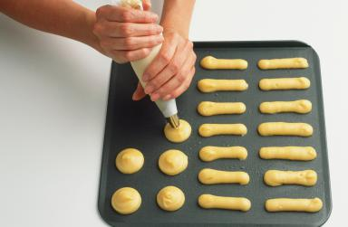 Piping choux pastry dough. Dave King / Getty Images

{profiteroles with coffee ice cream from epicurious}
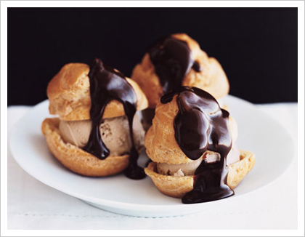

Paris Brest If you're not familiar with this classic French dessert it's a large ring of pâte à choux filled with a praline-infused pastry cream. They say the Paris-Brest was the brainchild of a very ingenious baker to commemorate the famous bicycle race between the two cities. Recipe of the one in this picture below is from cooks illustrated.
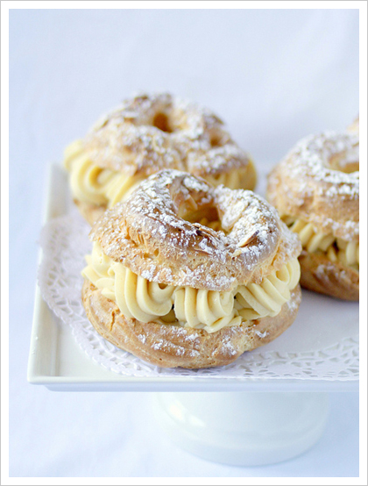

Churros 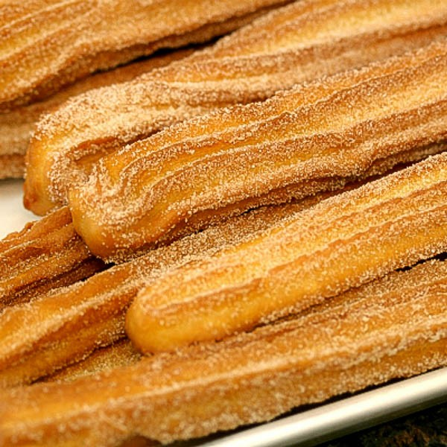

Source: Allrecipes.com (Recipe by:Delia)

Ingredients
- 1 cup water
- 2 1/2 tablespoons white sugar
- 1/2 teaspoon salt
- 2 tablespoons vegetable oil
- 1 cup all-purpose flour
- 2 quarts oil for frying
- 1/2 cup white sugar, or to taste
- 1 teaspoon ground cinnamon
- Add all ingredients to list

Directions
- In a small saucepan over medium heat, combine water, 2 1/2 tablespoons sugar, salt and 2 tablespoons vegetable oil. Bring to a boil and remove from heat. Stir in flour until mixture forms a ball.
- Heat oil for frying in deep-fryer or deep skillet to 375 degrees F (190 degrees C). Pipe strips of dough into hot oil using a pastry bag. Fry until golden; drain on paper towels.
- Combine 1/2 cup sugar and cinnamon. Roll drained churros in cinnamon and sugar mixture.

