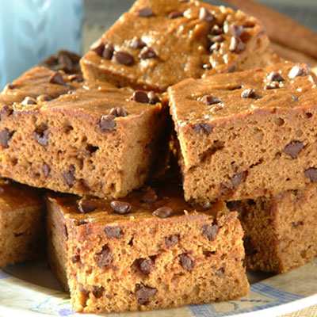
Pumpkin Chocolate Brownines
- Nonstick cooking spray
- 1/2 cup LIBBY'S® 100% Pure Pumpkin
- 1/3 cup brown sugar blend (such as SPLENDA)
- 1 large egg
- 2 large egg whites
- 2 tablespoons vegetable oil
- 1 cup all-purpose flour
- 1 teaspoon baking powder
- 1 teaspoon NESTLÉ® TOLL HOUSE® Baking Cocoa
- 1/2 teaspoon ground cinnamon
- 1/2 teaspoon ground allspice
- 1/4 teaspoon salt
- 1/4 teaspoon ground nutmeg
- 1/3 cup NESTLÉ® TOLL HOUSE® Semi-Sweet Chocolate Mini Morsels
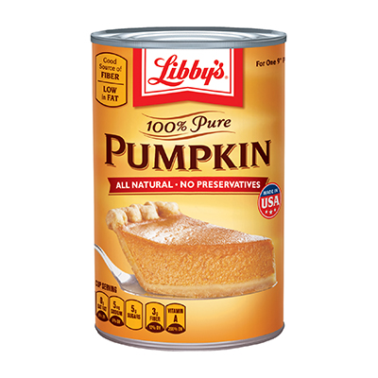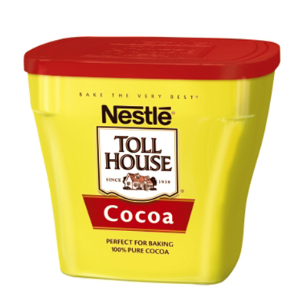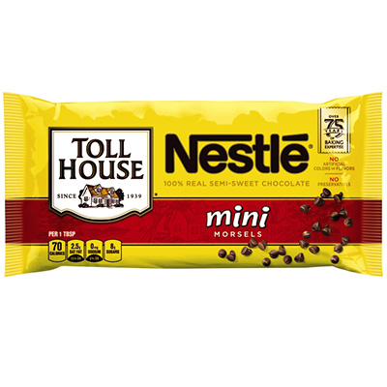

INSTRUCTIONS

PREHEAT oven to 350° F. Spray 8- or 9-inch-square baking pan with nonstick cooking spray.
COMBINE pumpkin, sugar blend, egg, egg whites and oil in large mixer bowl. Beat with an electric mixer on medium speed until blended. Add flour, baking powder, cocoa, cinnamon, allspice, salt and nutmeg. Beat on low speed until batter is smooth. Stir in morsels. Spread evenly into prepared pan.
BAKE for 25 to 30 minutes or until wooden pick inserted near center comes out clean. Cool in pan on wire rack. Cut into 2-inch squares.

