Red Velvet Whoopie Pies

YIELD APPROXIMATELY 18 SANDWICH COOKIES
Source: http://everydayannie.com/2010/02/08/red-velvet-whoopie-pies/

INGREDIENTS
For the cookies:
- 2 cups all-purpose flour
- 2 tbsp. cocoa powder
- ½ tsp. baking powder
- ¼ tsp. salt
- 8 tbsp. unsalted butter, at room temperature
- 1 cup light brown sugar, packed
- 1 large egg
- 1 tsp. vanilla extract
- ½ cup buttermilk, at room temperature
- 1 oz. red food coloring
For the frosting:
- 8 oz. cream cheese
- 5 tbsp. unsalted butter, at room temperature
- 2 tsp. vanilla extract
- 2½ cups confectioners’ sugar, sifted

DIRECTIONS
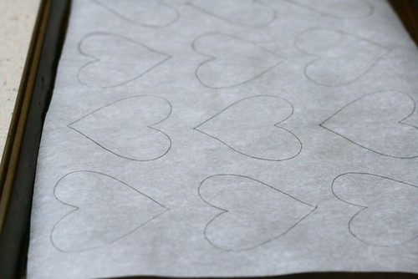
- 01
Preheat the oven to 375˚ F. Using a heart template cut out from card stock, trace evenly spaced hearts onto pieces of parchment paper sized to fit two cookie sheets. Place the parchment on the cookie sheets so that the side you have drawn on is facing down; set aside.

- 02
In a medium bowl, whisk together the flour, cocoa powder, baking powder and salt. In the bowl of a stand mixer fitted with the paddle attachment, cream together the butter and brown sugar on medium-high speed until light and fluffy, about 2 minutes. Beat in the egg until incorporated, scraping down the sides of the bowl as necessary. Blend in the vanilla. With the mixer on low speed, beat in about a third of the dry ingredients, followed by half of the buttermilk, beating each addition just until incorporated. Repeat so that all the buttermilk has been added and then mix in the final third of dry ingredients. Do not overbeat. Blend in the food coloring.
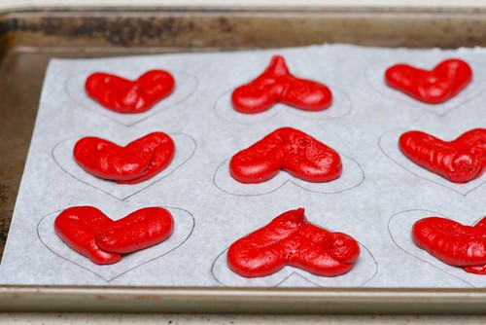
- 03
Transfer the batter to a pastry bag fitted with a large plain round tip. Pipe the batter onto the parchment paper using the heart tracings as a guide. Bake 7-9 minutes or until the tops are set, rotating the baking sheets halfway through. Allow the cookies to cool on the baking sheets at least 10 minutes, until they can be easily transferred to a cooling rack. Repeat with any remaining batter. Allow cookies to cool completely before proceeding.
- 04
To make the cream cheese frosting, in the bowl of a stand mixer fitted with the paddle attachment beat the cream cheese and butter on medium-high speed until well combined and smooth, about 2-3 minutes. Mix in the vanilla extract. Gradually beat in the confectioners’ sugar until totally incorporated, increase the speed and then beat until smooth.
- 05

Transfer the frosting to a clean pastry bag fitted with a plain, round tip. Pair the cookies up by shape and size.

- 06
Flip one cookie of each pair over so that the flat side is facing up.
- 07
Pipe frosting onto the flat-sided cookie of each pair, leaving the edges clear. Sandwich the cookies together so the flat sides are facing each other and press gently to help the filling reach the edges. To store, refrigerate in an airtight container.

