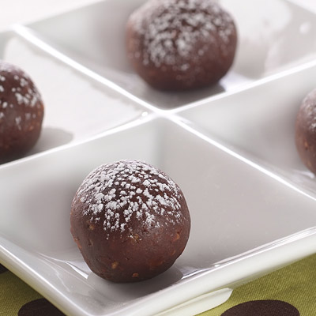
Rich Chocolate Pumpkin Truffles

- 2 1/2 cups crushed vanilla wafers (about 62)
- 1 cup ground, toasted almonds
- 3/4 cup powdered sugar, divided
- 2 teaspoons ground cinnamon
- 1 cup NESTLÉ® TOLL HOUSE® Semi-Sweet Chocolate Morsels, (6-oz) melted*
- 1/2 cup LIBBY'S® 100% Pure Pumpkin
- 1/3 cup coffee liqueur**
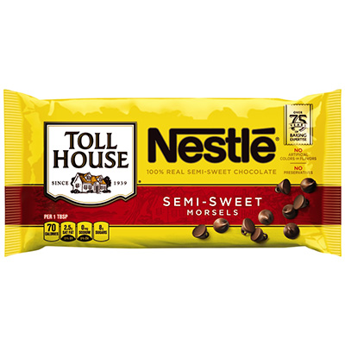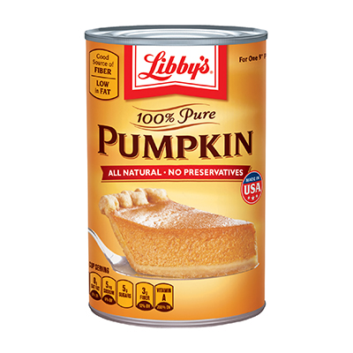

INSTRUCTIONS

COMBINE crushed cookies, ground almonds, 1/2 cup powdered sugar and cinnamon in medium bowl. Blend in melted chocolate, pumpkin and coffee liqueur. Shape into 1-inch balls. Refrigerate. Dust with remaining powdered sugar just before serving.
* Follow melting direction on NESTLÉ® package.
**1/3 cup apple juice can be used instead of coffee liqueur.

