THE BEST CHOCOLATE CHIP COOKIES – REALLY!
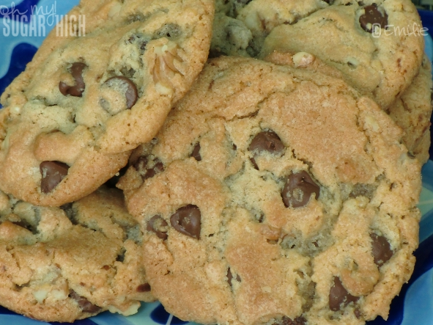

INGREDIENTS
3/4 cup shortening
1 cup brown sugar
1/2 cup sugar
2 eggs
1 teaspoon vanilla
2 1/4 cups flour
1 teaspoon salt
1 teaspoon baking soda
1 cup chocolate chips (milk chocolate or chocolate chunks are our favorite!)
1 cup chopped walnuts (optional)

DIRECTIONS
Beat shortening, brown sugar and white sugar together until creamy.
Add eggs and vanilla and beat well.
In separate bowl stir together flour, salt and soda and add to sugar and egg mixture. Mix well.
Add chocolate chips and walnuts if desired and stir.
Drop by tablespoons (or larger if you like) on cookie sheet. I highly recommend cooking them on parchment paper. No added grease and they come off so easily! (Not to mention a super simple cleanup!)
Bake at 350 degrees for 12-15 minutes or until golden brown, enjoying the lovely aroma now in your kitchen. Cool for a minute or so before transferring to a wire rack to cool completely.

