The History of Irish Soda Bread

Soda bread is a soft textured cake like bread that rises due to the reaction of the acid of a liquid like buttermilk, and a base like baking soda. Although the Irish didn't invent Soda Bread it is most often identified with them. The "soft wheat" is the only suitable flour that can grow in Ireland's climate, and when mixed like a traditional dough it doesn't form any gluten like a traditional yeast bread, it does work well with a soda bread recipe.

The Idea of using soda to leaven bread was done by the American Indians centuries ago, where they used pearl-ash or Potash ( a natural soda in wood ashes) ) in their breads to make them rise. The cross on the soda bread has several explanations, Legend has it that folks did it to "let the devil out" while it's baking for good luck, and others say that it made it easy to divide into 4 pieces. It was also a symbol for a cross during Christian holidays.

One of the earliest recorded publications of soda bread was in 1916. The editor of "The Gentleman's Magazine" in England was challenged to come up with a way to use poor soft wheat to make a bread.
He tried several experiments with his baker and came up with a bread using half wheat and half mashed up potato and soda ash instead of the usual yeast leavening.

In 1824 "The Virginia Housewife" by Mary Randolph was published. It contained a recipe for Soda Cake. Very possibly it was taught to Colonists in the states by the Native Americans.
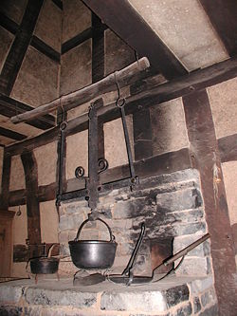
....Dissolve half a pound of sugar in a pint of milk, add a tea-spoonful of soda; pour it on two pounds of flour--melt half a pound of butter, knead all together till light, put it in shallow moulds, and bake it quickly in a brisk oven.

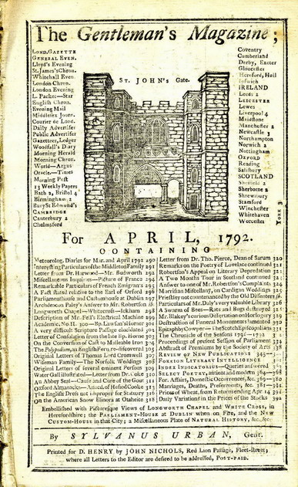
Unlike England where bread was made in Bakeries The Irish felt it was a housewife's job.
Her all purpose cast iron Dutch oven like pot they called a "Bastible " was better suited for soda bread, which hung
over a fire on a crane, as opposed to the Brick ovens that were used to bake the yeast breads in Europe.

Source: http://www.kitchenproject.com/history/IrishSodaBreads/index.htm

