Valentine's Day Heart Treats

By: Family Fun Magazine
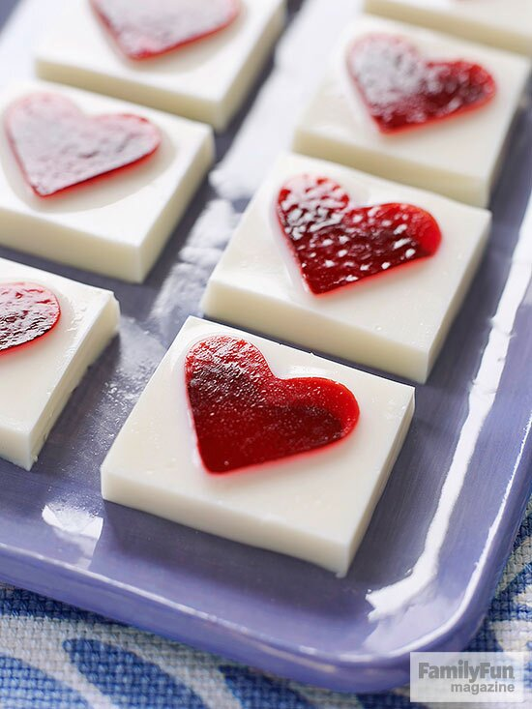

Coat a 9- by 13-inch pan with cooking spray. Prepare 4 (3-ounce) boxes of red gelatin according to package directions, pour it into the pan, and refrigerate for 2 hours. Loosen the edges of the gelatin with a spatula and invert it onto a cutting board. Use a mini cutter (ours is 1 1/2 inches) to shape it into hearts. Clean, dry, and respray the pan, then arrange the hearts in it, spacing them evenly.
In a medium bowl, sprinkle 2 envelopes of unflavored gelatin over 1/2 cup cold water. Let it sit for 1 minute, then stir in 1 1/2 cups boiling water and 1 (14-ounce) can sweetened condensed milk. Use a spouted bowl or cup to pour the mixture around, but not over, the gelatin hearts (you may have some mixture left over). Refrigerate the dessert until firm, about 2 hours. To serve, cut into squares.

