Why Irish Americans eat corned beef and cabbage, not bacon and cabbage…
Amanda Driscoll @IrishCentral February 17, 2017 12:00 AM Irishcentral.com Facebook Email Twitter Pinterest 7 Comments
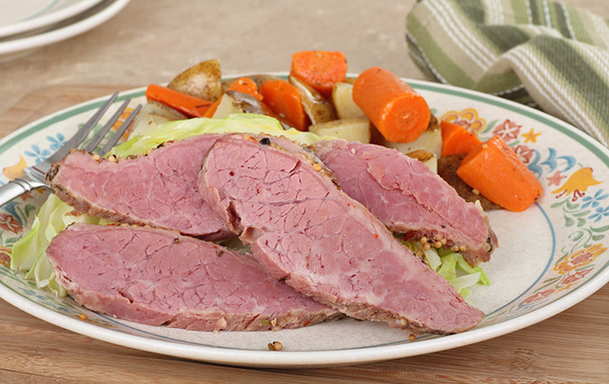
The Irish American tradition of eating corned beef and cabbage, rather than the
In every Irish establishment, and many others, especially around St. Patrick’s Day, corned beef and cabbage will make its way onto the menu, marking a "tip of the cap" to the Irish around March 17. Another annual occurrence is Irish people complaining that this is not, in fact, an Irish dish at all, but is this true?

Beef was not readily available in Ireland and was considered a luxury and that’s why the traditional Irish meal centered around ham, the bacon. But when these Irish got off the boats in America it was quite the opposite. Corned beef was the meat that they could easily and more cheaply get their hands on and, so, this became the meal of choice for generations of Irish Americans to come.

In New England, a tradition formed of having a boiled dinner. For this dish, the corned beef, cabbage, and root vegetables such as carrots, turnips, and potatoes were boiled.

Many maintain that the dish is simply not Irish at all. The close proximity of the Irish and Jewish communities at the time is said to be largely responsible for the popularity of corned beef among the Irish immigrants. According to thekitchenproject.com, when the Irish arrived in America, they couldn’t find a bacon joint like they had in Ireland so they gravitated toward the Jewish corned beef, which was very similar in texture.

